**Expressions & Functions:**

Like in other programming languages, here also you can have expressions and inbuilt functions e.g. concat() to concat two or more string . Expressions represents as @ symbol. I am sure same things you have used in SSIS, SSRS, SQL, C#, excel and other programming languages.

Here is list of categories of ADF:

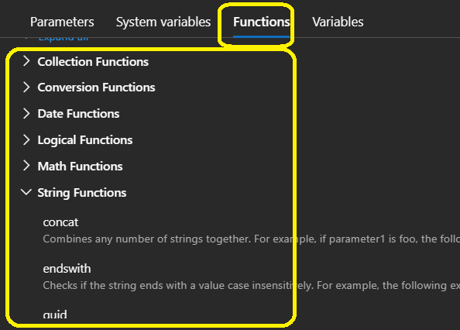

Examples:

1. Generated File/Sink name should have a predefined name e.g “BO1_DDMMYYYY”

Here every time your pipeline run, it have different name but still can identified it based on prefix- “BO1_”.

1. Container name should be concatenate with “-in”

@concat(“yourcontainer”, ‘-in’)

1. Nested If is not possible so we need to use expression in that case

@iif(“condition1”, Tru_Result, iif( “False_Condition”, True_Result, False_Result))